Supplementary Information S2 : Characterisation of root growth dynamics
Our objective is to differentiate between mature and growing (apex) root zones based on temporal variations in surface area. We operate on the assumption that root elongation and expansion occur dynamically during an initial active phase, followed by a period of physiological stabilization or growth deceleration.
By quantifying surface area increments ($Δ$) across increasing time lags, we can identify the inflection point where the rate of new surface accumulation begins to decelerate. This threshold defines the temporal window used to distinguish “newly emerged” functional segments from the established root network.

Surface area normalization
To convert root occupancy from digital units (pixels) to physical metric units ($cm^{2}$), we account for the scanner resolution (1200 dpi). The conversion factor is derived from the linear resolution: $1200\text{ dpi}/2.54\text{ cm/in}≈472.44\text{ pixels/cm}$.
The surface area in $cm^{2}$ is calculated as:
$$Surface\left(cm^{2}\right)=Pixels/{\left(472.44\right)}^{2}$$

Visualization of root surface trends
The following plot displays the evolution of total root surface area across the curated image bank, faceted by scanner unit :
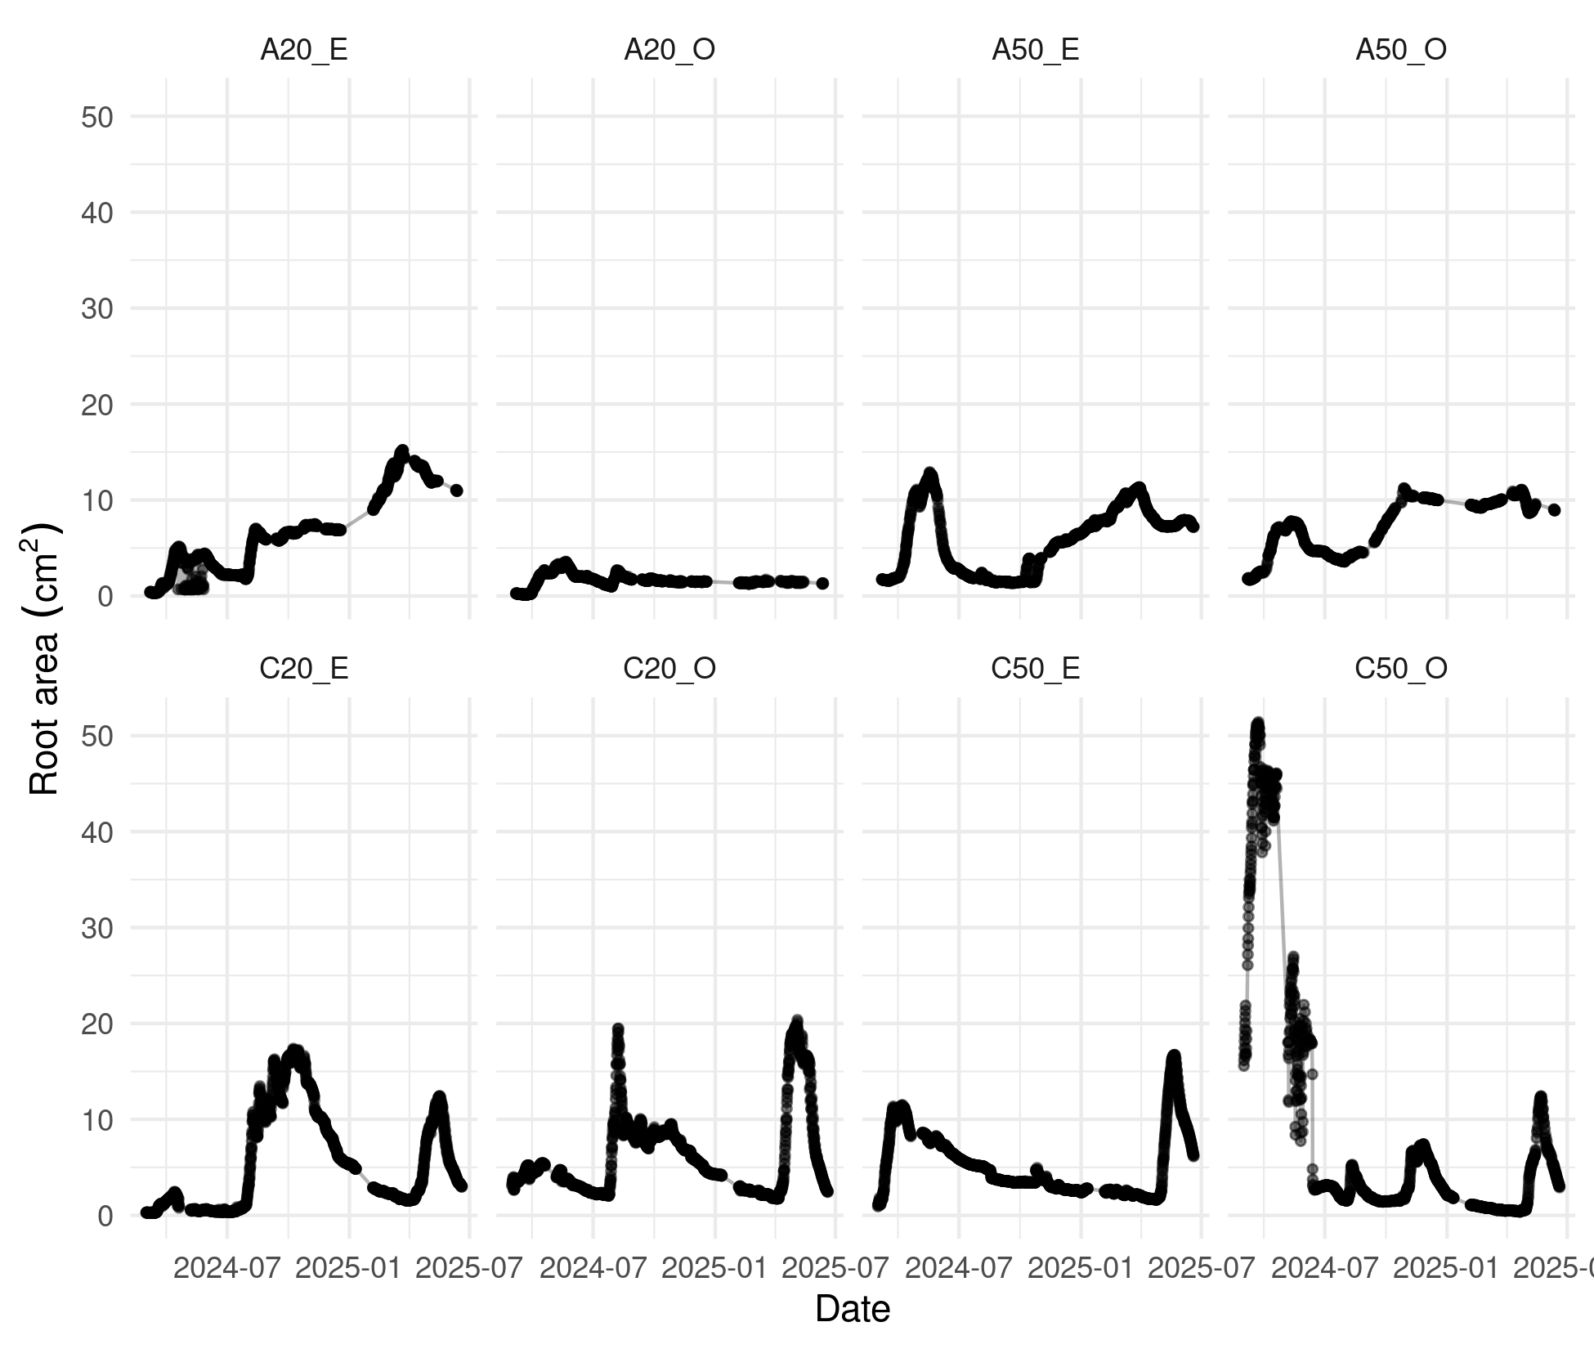
Root Surface Area Evolution

Quantification of apex surfaces according to time lags
The difference in surface area between two successive observations represents newly emerged root tissue (the apices). We analyzed the distribution of surface increments ($Δcm^{2}$) across intervals ranging from 6 to 720 hours (30 days). We applied an Interquartile Range (IQR) filter to remove extreme outliers in surface density that could skew growth estimates. Only positive increments are retained to represent growth; negative deltas—resulting from experimental noise or root decomposition—are normalized to zero.
The average apex areas as a function of time step are shown, along with their variability (standard deviation). An initial average is calculated by scanner, then the values are aggregated:
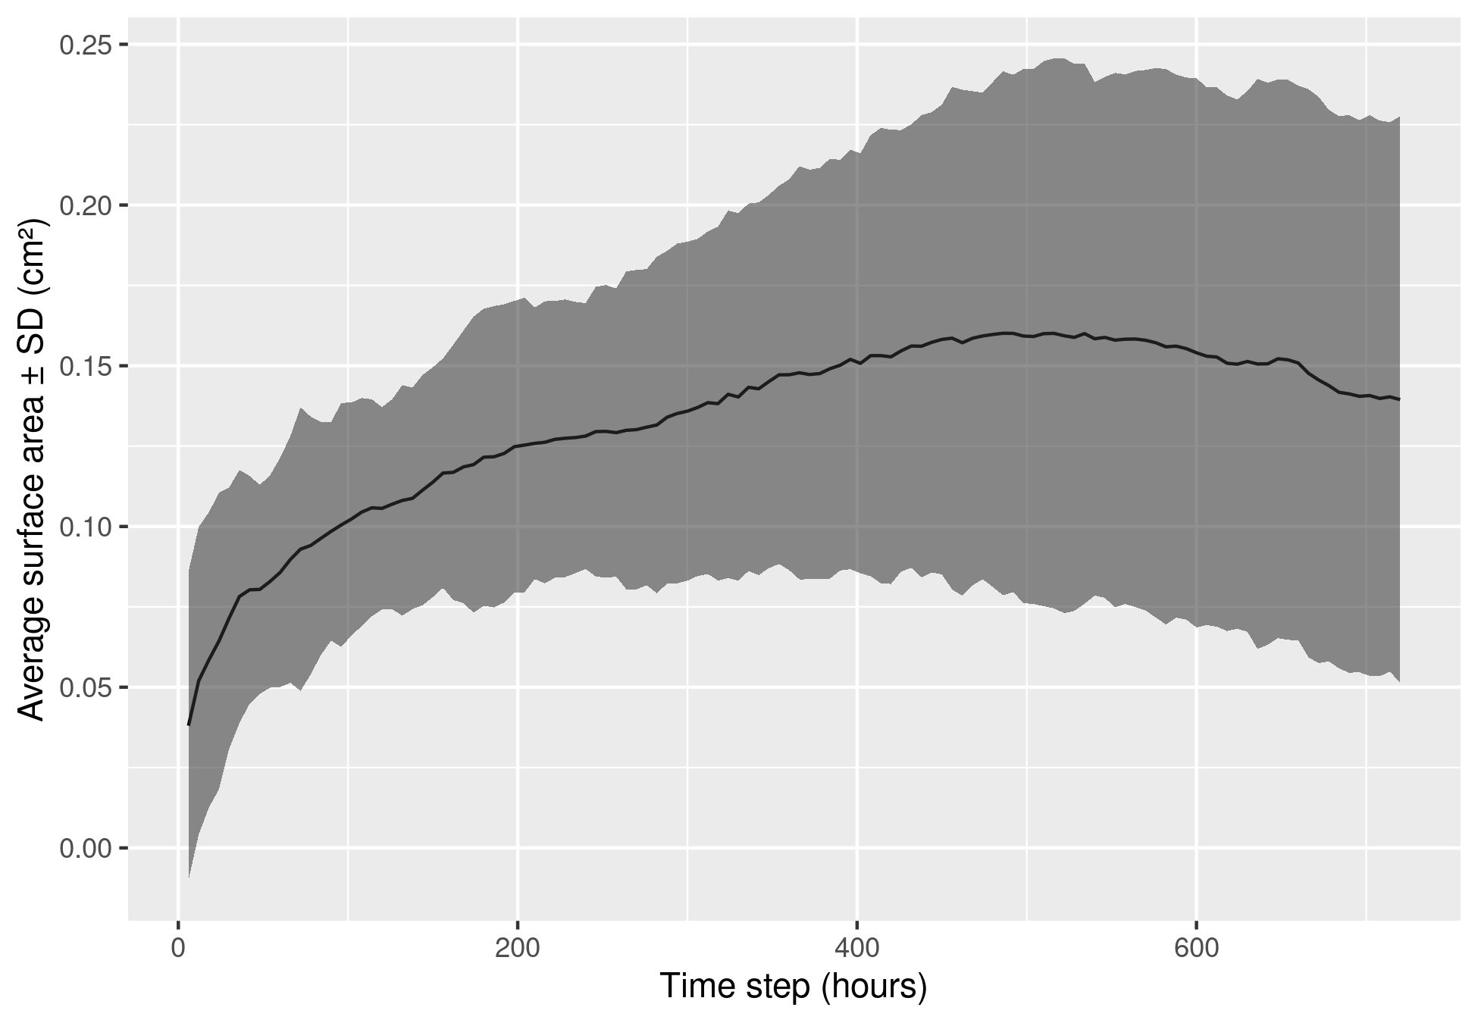
Root Surface Area Evolution

Statistical Modeling and Threshold Detection
- To formally identify the transition from active growth to stabilization, we employed a Generalized Additive Model (GAM), which allows for the flexible modeling of the non-linear relationship between the time lag and the accumulated surface area of the apices.
- We pinpointed the growth inflection point by calculating the first derivative ($f′\left(x\right)$) of the estimated smooth function.
- The first derivative represents the instantaneous rate of growth accumulation, while the inflection point is identified at the specific lag where this derivative crosses zero. Such a crossing into negative values indicates a distinct phase change, signaling a transition from active expansion to a growth slowdown or a net loss of visible surface area.
thresholds : 9 days
The first derivative of the model reveals that the rate of accumulation decelerates sharply as it approaches the 9-day (216-hour) mark. At this temporal juncture, the growth curve transitions from an active expansion phase to a relative plateau. Beyond this 216-hour threshold, any ‘newly’ observed surface area likely reflects the stabilization of established tissue or secondary thickening rather than primary apical elongation.
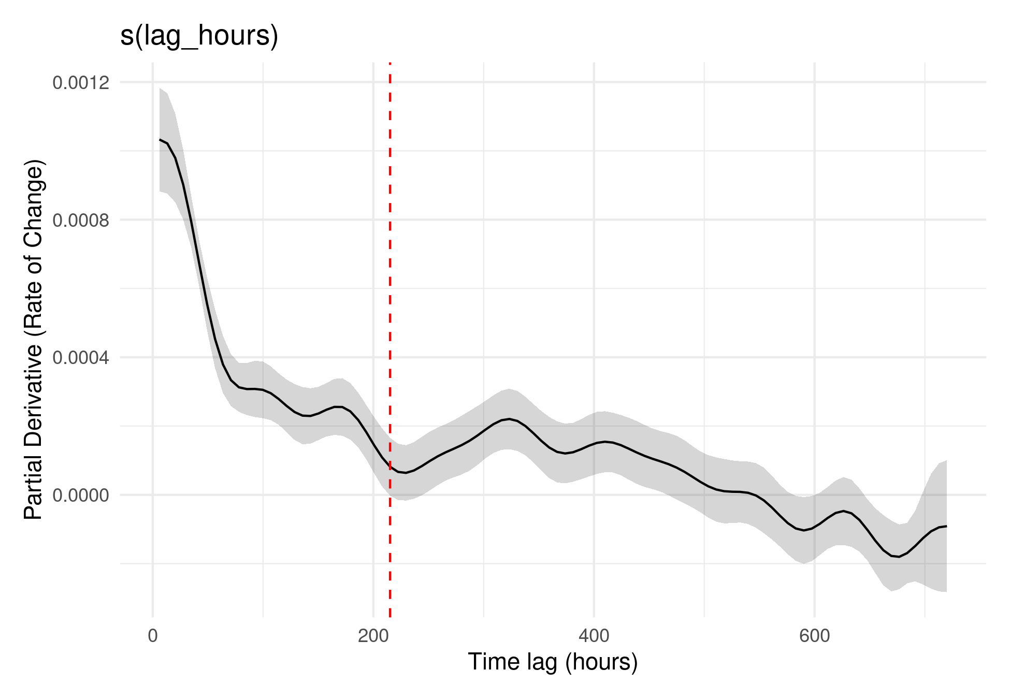
Red line indicates chosen 9-day threshold
Estimated First Derivative of Growth Curve
This 9-day interval serves as a functional boundary to distinguish highly active apical zones from more stable, mature root segments.

